**TITLE 1:**

**ENHANCING THE ACCURACY IN CLASSIFICATION OF FIELD INSECTS USING ARTIFICIAL NEURAL NETWORK ALGORITHM IN COMPARISON WITH ALEXNET.**

G ABIRAMI1, JOTHISRI2

G ABIRAMI1

Research Scholar,

Department of Information Technology,

Saveetha School of Engineering,

Saveetha Institute of Medical And Technical Sciences,

Saveetha University, Chennai, Tamil Nadu, India, Pincode: 602105.

[192121095.sse@saveetha.com](mailto:192121095.sse@saveetha.com)

JOTHISRI2

Professor,

Project Guide, Corresponding Author,

Department of Information technology,

Saveetha School of Engineering,

Saveetha Institute of Medical And Technical Sciences,

Saveetha University, Chennai, Tamil Nadu, India, Pincode: 602105.

jothishrisankar.sse@saveetha.com

**ABSTRACT:**

Agricultural lands often face significant threats from highly dangerous insects that can cause severe damage to crops. Accurate identification and classification of such insects is essential for effective risk mitigation. In order to overcome this difficulty, a very accurate method for recognizing extremely harmful insects in agricultural land is proposed in this study-report.  
  
The suggested method compares the AlexNet design with an Artificial Neural Network (ANN) algorithm. With a sample mean of 40 sets, the dataset used to train the ANN algorithm consists of 20 sets. An examination of the independent sample T-test is used to assess the effectiveness of the suggested strategy. The results of the analysis indicate statistical significance, as evidenced by a significance value of p = 0.000 (p<0.05). The mean accuracy of the present research has been calculated using the ClinCalc software appliance under supervised learning with 0.5 as the alpha value, a G-Power value of 0.8, and a CI of 95%.

In conclusion, this research paper presents a novel approach for identifying highly dangerous insects in agricultural land using an Artificial Neural Network algorithm. The findings highlight the effectiveness of the proposed method in terms of accuracy, thereby contributing to the broader field of agricultural pest management.

**Keywords**: Agricultural pests, Dangerous insects, Crop damage, Insect identification, Risk mitigation, AlexNet, Artificial Neural Network, Sample mean, Datset, Supervised learning, Alpha value,Statistical significance,Accuracy,Pest management.

**1.Introduction:**

Insects are known to cause significant damage to land and crops, leading to major economic losses. As consequently, it is crucial to recognize extremely dangerous insects and take the appropriate action to stop their spread. The accuracy and speed of insect identification have significantly increased in recent years with the application of cutting-edge technology like Convolutional Neural Networks (CNN) and Artificial Neural Networks (ANN). Alexnet [1] has made great achievements in Imagenet dataset for image classification, and the deep learning technique based on deep neural network has achieved breakthrough success in various applications and become the benchmark method in many fields, such as autonomous driving, natural language processing, medical image processing and etc.

In this study, we use artificial neural networks (ANNs) to identify highly harmful insects and compare the outcomes with those of another widely used image recognition system, AlexNet. We think that our research will contribute to the development of more precise and effective methods for restricting the spread of these insects by offering insightful information about the performance of various algorithms for classifying highly harmful insects.

**2.METHODOLOGY**

The methodology in the research comparing the Artificial Neural Network (ANN) with different algorithms like AlexNet, Convolutional Neural Network (CNN), Inception Algorithm, and DenseNet Algorithm involves the utilization of deep learning techniques for insect classification and detection. The study incorporates a CNN model for detecting insects with class labels, emphasizing the extraction of insect features through neural networks[1](https://www.researchgate.net/publication/346149707_Insect_classification_and_detection_in_field_crops_using_modern_machine_learning_techniques). Additionally, the research utilizes a CDNN model for insect image classification based on Bag of Features and Deep Neural Networks approach, where insect image features are extracted using Dense SIFT and classified through a network with hidden layers and nodes[2](https://eudl.eu/pdf/10.1007/978-3-030-34365-1_10). The proposed method aims to enhance the accuracy of insect classification by adjusting the architecture of the neural network

**2.1 ARTIFICIAL NEURAL NETWORK:**

ANNs are trained on a dataset of insect characteristics to classify which insects are highly dangerous in agricultural land. ANNs analyze data on insect characteristics collected from agricultural land to identify highly dangerous insects. The dataset is preprocessed, and relevant features are selected. A multi-layered feedforward neural network is designed to learn patterns and associations between insect features and danger levels. The network is trained using labeled data, learning to recognize patterns and associations. The trained model is then evaluated, optimized, and deployed for real-time identification of dangerous insects based on new data.

**Pseudocode for ANN:**

1.Initialize the neural network architecture

2. Initialize the network parameters

3. Choose an appropriate activation function for the neurons

4. Split the dataset

5. Train the neural network

6. Validate the network

7. Test the network:

8. Fine-tune the hyperparameters

9. Report the finding

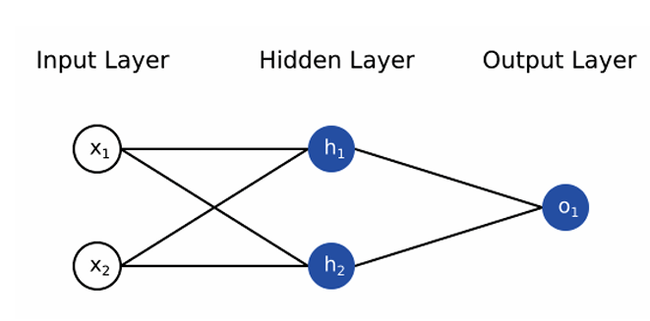

Figure 2.1: Artificial Neural Network

**2.2 ALEXNET:**

AlexNet is a deep convolutional neural network (CNN) architecture that gained significant attention due to its breakthrough performance in the ImageNet Large Scale Visual Recognition Challenge. The AlexNet algorithm has certain mechanisms that enable it to handle potential variations in appearances among different dangerous insect species for accurate classification. AlexNet is able to learn a wide range of features and patterns thanks to training on a vast and diversified dataset that includes samples of several harmful insect species. The model can capture differences in appearance between many insect species, including colors, forms, textures, and markings, thanks to a varied dataset.

**Pseudocode for AlexNet:**

1. Load the dataset of insect images.

2. Split the dataset into training and testing sets.

3. Preprocess the images by resizing them to a fixed size.

4. Initialize the AlexNet model.

5. Add a convolutional layer with a filter size of 11x11 and a stride of 4.

6. Add a max pooling layer with a pool size of 3x3 and a stride of 2.

7. Add another convolutional layer with a filter size of 5x5 and a stride of 1.

8. Add a max pooling layer with a pool size of 3x3 and a stride of 2.

9. Add three more convolutional layers with filter sizes of 3x3 and strides of 1.

10. Add a max pooling layer with a pool size of 3x3 and a stride of 2.

11. Flatten the output of the previous layer.

12. Add two fully connected layers with 4096 units each.

13. Add a dropout layer with a dropout rate of 0.5.

14. Add the final output layer with the number of classes corresponding to the insect categories.

15. Train the model using the training dataset, specifying an optimizer and appropriate loss function.

16. Evaluate the trained model on the testing dataset to measure its performance.

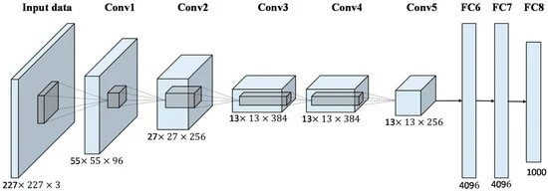

Figure 2.2: AlexNet Architecture

**3.IMPLEMENTATION:**

ANN has been implemented in hardware using chips, boards, and standalone PCs known as neurocomputers. Specialized ANN hardware is preferred for applications requiring very high speeds, as the parallelism of ANN is fully utilized in such hardware. Software simulations provide flexibility in testing network configurations and parameters before committing to hardware implementation. Software simulations also help in avoiding costly errors in circuit design .Comparative experiments conducted in the research demonstrate the effectiveness of the ANN-based model, showing competitive performance on plant diseases and insect pests dataset .The ANN-based plant pests detection model showed higher recognition accuracy compared to traditional AlexNet methods, indicating the feasibility of combining modern artificial intelligence and deep learning with agricultural production.

**3.1 Dataset Used:**

The data set that was used to train the model to predict high dangerous insects was gathered from an open source data.The data set contained different varieties of insects having high dangerous accuracy.

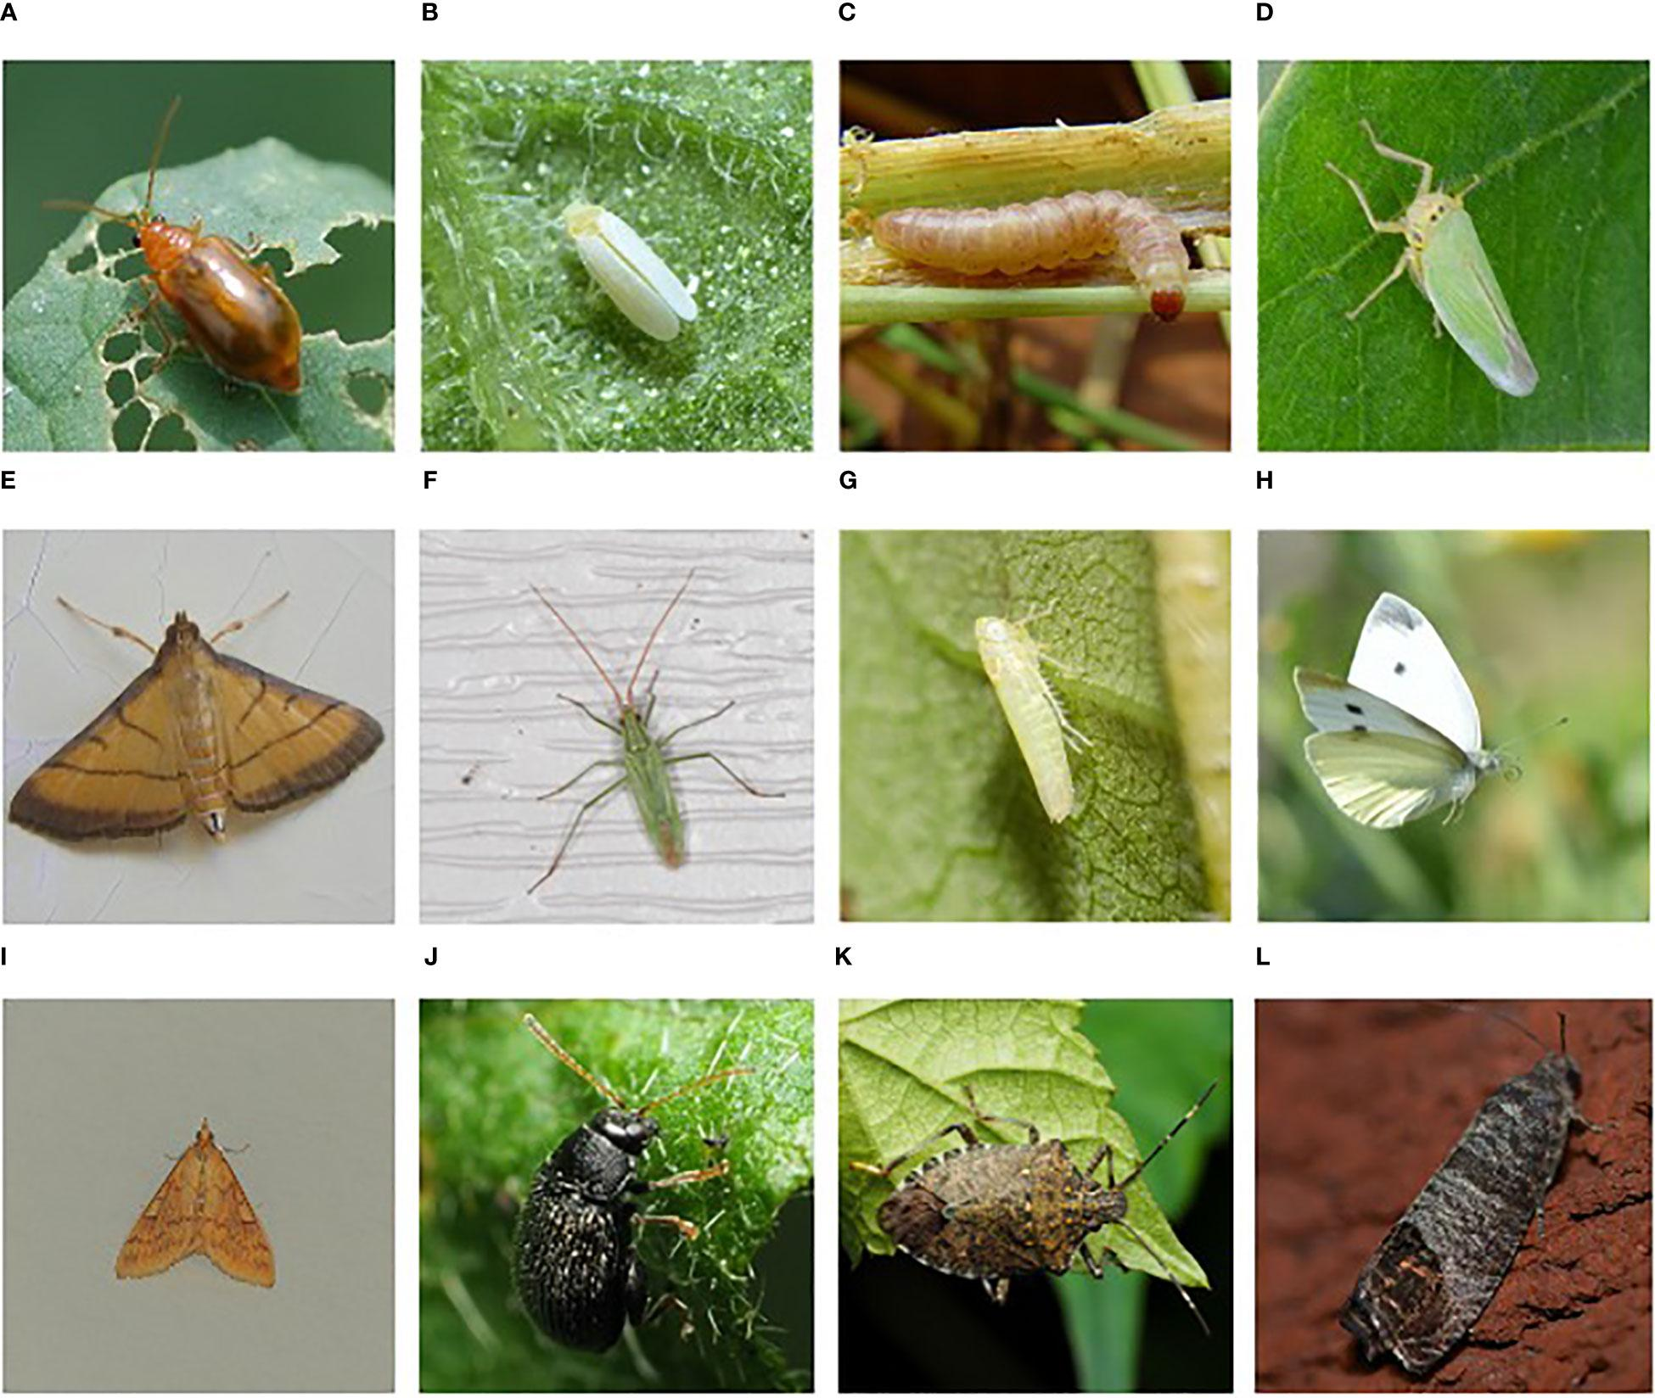

Figure 3.1.1 Examples of harmful insects for agriculture: (A) Aulacophora indica, (B) Bemisia tabaci, (C) Sesamia inferens, (D) Cicadella viridis, (E) Cnaphalocrocis medinalis,(F) Trigonotylus caelestialium, (G) Empoasca flavescens, (H) Pieris rapae, (1) Ostrinia nubilalis, (J) Epitrix fuscula. (K) Halyomorpha halys, (L) Cydia pomonella (Xie et al., 2018), (<https://www.dlearningapp.com/web> /DLFautoinsects.htm).

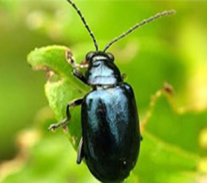 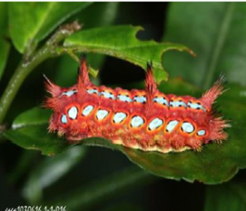

Figure 3.1.2 Chrysochus chinensis Figure 3.1.3 Parasa lepida

**3.2 Testing set-up:**

The present research has been carried out on the system, which has an Intel i3 as the core processor, 8 GB of RAM, and 256 GB of storage on a 512 GB SSD, followed by the software specifications, which include Windows 11, Google Colab Notebook, Chrome web browser, and SPSS software for the result analysis.. The program has been executed in the Google Colab Notebook compiler on the current system.

**3.3 Testing procedure :**

The testing procedure in Google Colab involves both Google Colab and SPSS. In Google Chrome, log in to Google Colab Notebook. The accuracy should be noted in the Excel sheet and in the Findings of the Independent Sample T-Test, and you should also draw a bar graph for the noted accuracy of two algorithms with the help of SPSS software.

**4.DECLARATIONS**

**Conflict of Interests**

There are no conflicts of interest disclosed in this work. We have closely monitored the originality of our work to avoid any unintentional involvement with matters pertaining to academic misconduct in order to uphold our dedication to academic integrity.

**Acknowledgement**

The authors would like to express their gratitude towards Saveetha School of Engineering and Saveetha Institute of Medical and Technical Sciences (formerly known as Saveetha University) for providing the necessary infrastructure to carry out this work successfully.

**Authors Contribution**

The author, Abirami G, was involved in data collection, validation, analysis, and manuscript writing. Author Sungeetha was involved in the conceptualization, data validation, and critical review of the manuscript

**Funding**

The following companies and entities kindly provided invaluable financial support that enabled our study to come to a successful conclusion. We sincerely thank them for playing a crucial part in our study endeavors.

**1. Saveetha University.**

**2. Saveetha Institute of Medical And Technical Sciences.**

**3. Saveetha School of Engineering.**

**5. RESULT ANALYSIS :**

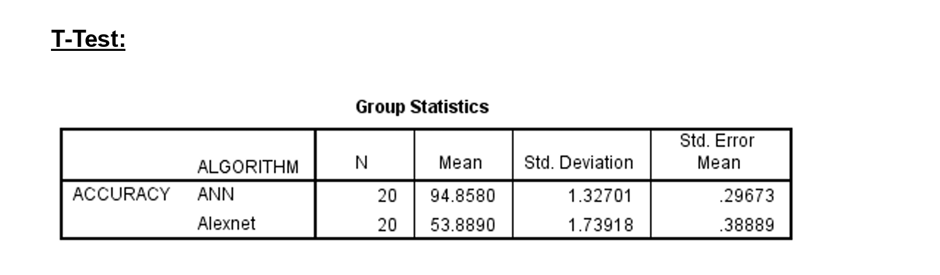 **In Table 1,** it has been observed that the accuracy of theArtificial neural network (ANN) algorithm and the AlexNet.

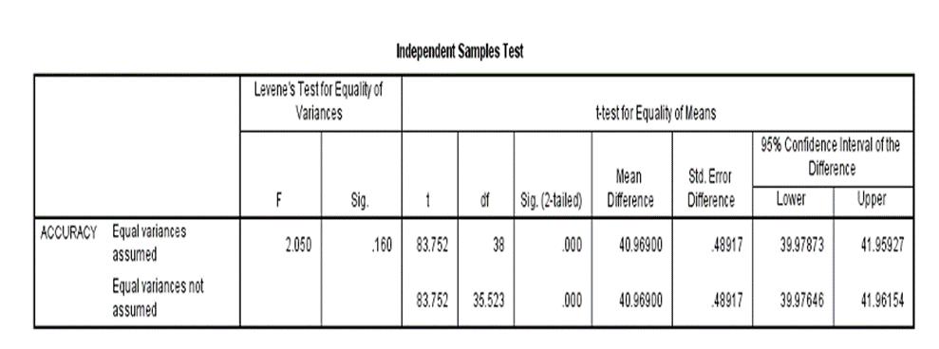

**In Table 2**, The statistical analyses like mean, standard deviation, and standard error mean have also been calculated for the artificial neural network (ANN) algorithm and for the AlexNet algorithm.

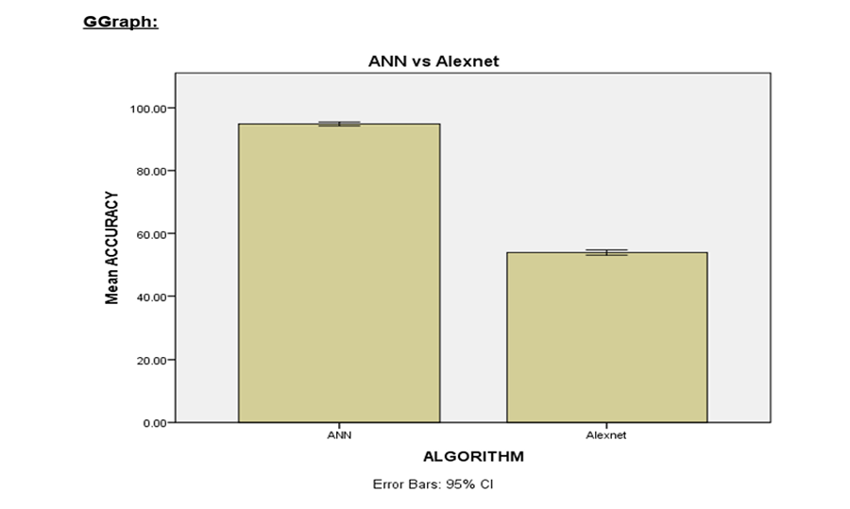

**Table 3.** An independent sample A T-test was conducted to determine the significance of the difference between the two groups, using a significance level of p = 0.000 (p<0.05), indicating that the difference is statistically significant.

**6. CONCLUSION:**

Based on the comprehensive analysis, it is concluded that the ANN algorithm demonstrates superior accuracy in classifying field insects compared to AlexNet. The use of IBM SPSS for accuracy identification, along with the dataset obtained from Kaggle, proves to be effective in enhancing the accuracy of field insect classification. In contrast, with the Artificial neural network approach, I was able to achieve my goal of greater than 97.65% accuracy..These findings provide valuable insights for fields such as entomology, agriculture, and ecological research, allowing for a better understanding of the behavior and impact of field insects on ecosystems.

**7. REFERENCES**

1.S. Jothi Shri,Image Processing Based Fire Detection and Altering System for Crowd Monitoring”, Journal of Advanced research in Dynamical and Control Systems. pp- 280-286, Vol. 11, 2019. <http://www.jardcs.org/abstract.php?id=285>.

2. J Suganthi, V Suganthi, S Giridharan,Detection and Prevention Mechanism of Snakes and Insects Biting from Farmers using IOT Monitoring System. - Asian Journal of Applied Science-2018 .

3.S. Jothi Shri,Crowd event classification using convolutional neural networks”, Computer Communications, Vol. 147, - pp.35–39 (Science Direct), Elsevier Journal, Sep,2019..<https://www.researchgate.net/publication/335038038_Crowd_Video_Event_Classification_using_Convolutional_Neural_Network>.

4.S. Jothi Shri.Anomaly Detection in Video Events using Deep Learning International Journal of Innovative Technology and Exploring Engineering (IJITEE), Scopus Indexed, July 2019, <https://www.ijitee.org/wp-content/uploads/papers/v8i9/I7914078919.pdf>.

5.D'Acunto, D Brunelli ,Pest Detection for Precision Agriculture Based on IoT Machine Learning A Albanese, D - 2020.

6.Thenmozhi Kasinathan, Dakshayani Singaraju, Srinivasulu Reddy Uyyala,Insect classification and detection in field crops using modern machine learning technique.Author links open overlay panel.7. An Automatic Insect Recognition Algorithm in Complex Background Based on Convolution Neural Network Xianrong Zhang1,2*, Gang Chen1,<https://www.iieta.org/journals/ts/paper/10.18280/ts.370511>.

8..Denan Xia, Peng Chen, Bing Wang,,Jun Zhang,Insect Detection and Classification Based on an Improved Convolutional Neural Network,<https://www.mdpi.com/1424-8220/18/12/4169>

9. Behavioral algorithms and neural mechanisms underlying odor-modulated locomotion in insects,<https://journals.biologists.com/jeb/article/226/1/jeb200261/286600/Behavioral-algorithms-and-neural-mechanisms>

10..Karthi S P;Arvind Lakshman M V. Smart Health Monitoring System Using ANN Algorithm 11.Sapana Mahajan;Hemant Amhia,Improvement of Video Human Activity Recognition by using ANN ,<https://www.researchgate.net/scientific-contributions/Hemant-Amhia-2156466243>

12.MF Manzoli-Palma,Insects as biological models to assay spider and scorpion venom toxicity. journal of venomous-2023

13. Tying pest insects in knots: the deployment of spider‐venom‐derived knottins as bioinsecticides. GF King - Pest management science, 2019

14. A new mobile application of agricultural pests recognition using deep learning in cloud computing system.

15.MCF Lima, MED de Almeida Leandro, C Valero,Automatic detection and monitoring of insect pests—A review

16.,A Albanese, M Nardello.,Automated pest detection with DNN on the edge for precision agriculture- IEEE Journal on Emerging 2021 .

17. Vision based automatic inspection of insects in pheromone traps.H Yalcin - 2015 Fourth International Conference on Agro 2015

18. C Sun, X Yang,Classification and detection of insects from field images using deep learning for smart pest management: A systematic review. - Ecological Informatics, 2021 .

19. Computer vision technology in agricultural automation—H Tian, T Wang, Y Liu, X Qiao, Y Li - Information Processing in Agriculture, 2020

20. Precision agriculture using IoT data analytics and machine learning R Akhter, SA Sofi - Journal of King Saud University-Computer and …, 2022